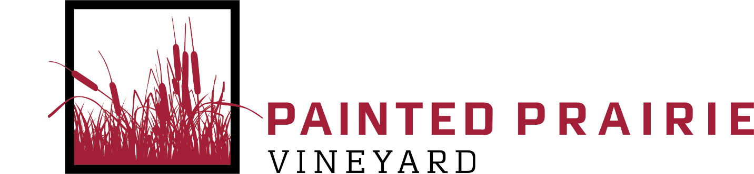

**Painted Prairie Vineyard Special Event Frequently Asked Questions  
2025**

**Pre-Event**

*How do I book my event at Painted Prairie Vineyard?*

The first step to booking your event is to find a date that works for you and the winery. If you would like to schedule a tour or start the booking process, reach out to Painted Prairie!

*After I book my event at Painted Prairie, what happens next?*

Once you book your event date, you will receive an agreement to sign and additional information on how to make the deposit for the rental.

*How much money is due at the time of the booking?*

An initial non-refundable down payment of half the rental fee (50%) is required at the time of booking and the second half is to be paid in full the day of the event. Bar tab and remainder rental fees will be paid the day of the event. Painted Prairie includes a 20% gratuity to the final bill on the day of the event.

*Does Painted Prairie have a non-profit discount?*

Painted Prairie Vineyard will work with organizations to create an event package to fit their needs and budgets. Please reach out to Painted Prairie Vineyard to discuss various event options.

**Day of the Event**

*Does Painted Prairie have decorations I can rent?*

Painted Prairie has a limited amount of decorations for use in the Pavilion and Red Barn. Please ask to see specifics during your visit to the winery. All decorating must have the approval of Painted Prairie staff. No wax candles can be lit in either spaces.

*Does Painted Prairie have tablecloths and napkins for use?*

Painted Prairie has white tablecloths for use and will be placed on the tables, if chosen. Painted Prairie provides black tablecloths on the buffet tables. If you choose to go with an outside vendor, it is your responsibility to have them placed on the tables. There are no linen napkins available at the Vineyard and must be brought in from an outside vendor.

*What can I expect on the day of the event?*

On the day of your event, you will be let into the building at the time arranged with Painted Prairie Vineyard. Depending on your package, there may be open tasting hours for the public. You can expect a staff person to be present with the event throughout the duration. Painted Prairie asks all guests leave by 11 p.m.

If it is a morning Pavilion event, the party must be done and cleaned up by 11:30 a.m. to allow time for staff to clean up and set up for open hours.

*Can we bring in our own drinks on the day of the event?*

All beverages (alcoholic and non-alcoholic) must be purchased through the winery and outside beverage are not allowed. RENTERS AND GUESTS ARE STRICTLY PROHIBITED FROM BRINGING OUTSIDE ALCOHOL ONTO PAINTED PRAIRIE WINERY PREMISES. A $1,000 corking fee will be added on the final bill if outside alcohol is found onsite by a guest during an event.

*What alcohol options are available to serve guests during events?*

Painted Prairie Vineyard has the ability to serve a full bar during a private event in the Pavilion and Red Barn. This can include wine, beer, and hard alcohol. Painted Prairie staff will work with you to select your final bar selections one month prior to your event.

*Can I or my guests park RVs or campers in the Painted Prairie parking lot and spend the night?*

Painted Prairie does not allow guests to spend the night on the winery premises. All guests of the winery should leave the grounds by 11:00 p.m.

*How does Catering work at Painted Prairie?*

For any event up to 150 individuals, a group must select a catering menu with Painted Prairie. For events of 150 or more individuals, an outside licensed catering company must cater the function. Desserts can be brought in by the party. For Pavilion rentals, a $125 kitchen fee will be added on the final bill if an outside catering company is used. It is the responsibility of the catering company to remove dishes and garbage.

*Where is parking available?*

Parking is available to guests by the Painted Prairie Pavilion and the Red Barn. Additional transportation may be arranged for handicapped guests onsite. Painted Prairie Vineyard staff will assist in directing parking.

*Is smoking permitted at Painted Prairie?*

Painted Prairie is smoke-free in all indoor and outdoor areas, except marked, designated smoking areas. Cigarette butts must be placed in the appropriate disposal unit. Vaping is allowed in designated areas.

*Are children allowed at Painted Prairie?*

Children are welcome but are the responsibility of their parents or guardians and must be supervised at all times. A one-time warning will be given in the event where a child has been left unsupervised and is found to be doing inappropriate activities (throwing rocks, damaging property, etc.). If the behavior continues, the child and their guardian(s) will be asked to leave the premise of Painted Prairie.

**Cost of the Event and on-site policies**

*Can I change my event package selection after booking?*

Painted Prairie will allow event packages to be changed up to six months prior to the event. Parties are responsible for paying the difference in down payment (if any) at the time of changing the package.

*Am I subject to any service fees payable to Painted Prairie staff?*

Painted Prairie includes an 20% gratuity to the final bill on the day of the event. There may be service fees associated with the catering.

*Is there a beverage minimum?*

For every private event, there is a minimum of a six-wine bottle purchase. There are no additional purchase requirements. Painted Prairie staff will work with each group to determine how alcohol purchases will be handled. It can be done open bar, a la carte, or 100% purchased by guests. Painted Prairie does not host dry events.

*Liability Insurance*

Painted Prairie requires a General Liability Certificate of Insurance covering the date of the event in the amount of $50,000 naming Painted Prairie as an additional insured and must be received two (2) weeks prior to the event. A general liability certificate can usually be obtained from your insurance or online broker.

*Underage Drinking; Other Illegal and Objectionable Behavior*

Underage drinking, use of illegal substances, and other illegal activity are prohibited on Painted Prairie Vineyard’s property, and such restrictions will be strictly enforced. Painted Prairie Vineyard expressly disclaims, and the client voluntarily assumes and agrees to indemnify and hold harmless Painted Prairie Vineyard from all responsibility and liability related to underage drinking, other illegal activity, and negligent or reckless behavior of the client and/or its guests while on or around Painted Prairie Vineyard’s property. Painted Prairie Vineyard reserves the right to refuse service to or demand that any or all guests leave the event and our property whenever we determine in our sole discretion that circumstances require it, including, without limitation, for failure to adhere to our rules, use of illegal substances or underage drinking, excessive consumption of alcohol or sound levels, threats of or actual violence, discrimination or other unhealthy, illegal, or otherwise objectionable behavior. In such an event, the client will remain fully responsible for all fees and payments owed to Painted Prairie Vineyard. Please just be thoughtful and respectful and this will likely never become an issue.

Contact Krista at Painted Prairie Vineyard for additional information. [krista@paintedprairiewine.com](mailto:krista@paintedprairiewine.com) or (507) 626-5203